Test Case: tc003_SPX_Dev5_Crear_Requisicion_Spot_Tipo_Cobro_CC_Urgent
Step 1 - Enter username and password and click to button Enter : Credentials Entered
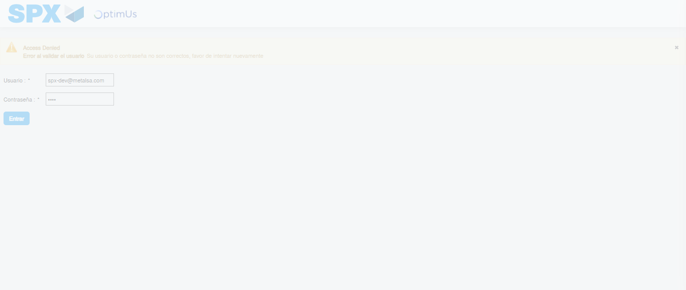Image file-name: QC_Testing-tc003_SPX_Dev5_Crear_Requisicion_Spot_Tipo_Cobro_CC_Urgent-1782242767421

Step 2 - Select to UEN and Access to Spot Buy Requisitions : UEN Correctly selected and Correct access
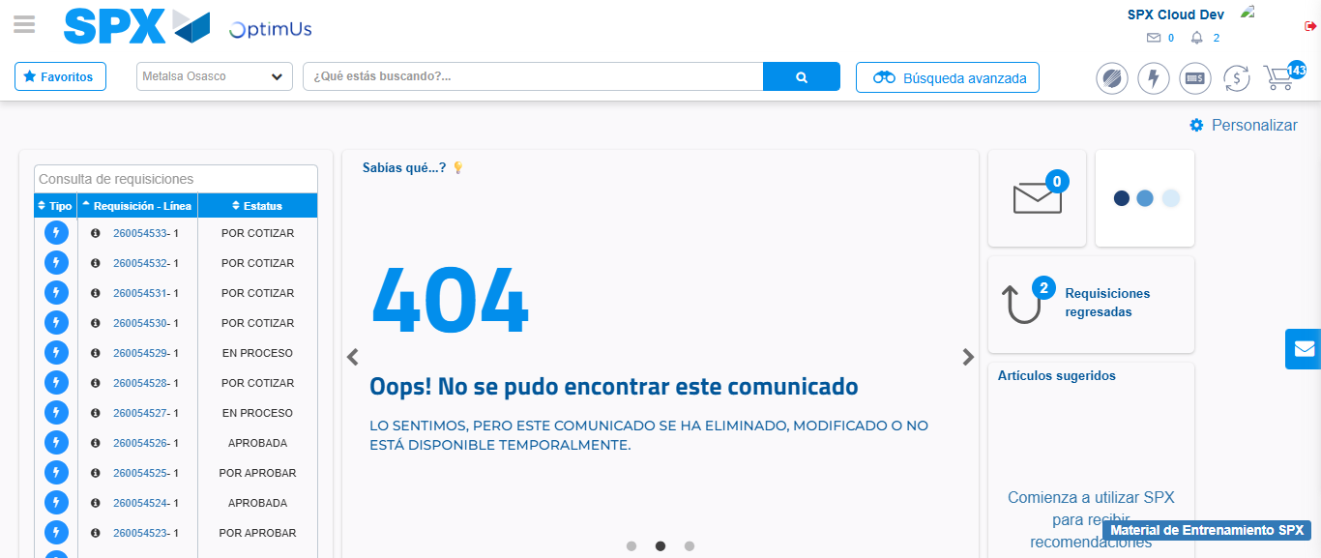Image file-name: QC_Testing-tc003_SPX_Dev5_Crear_Requisicion_Spot_Tipo_Cobro_CC_Urgent-1782242796056

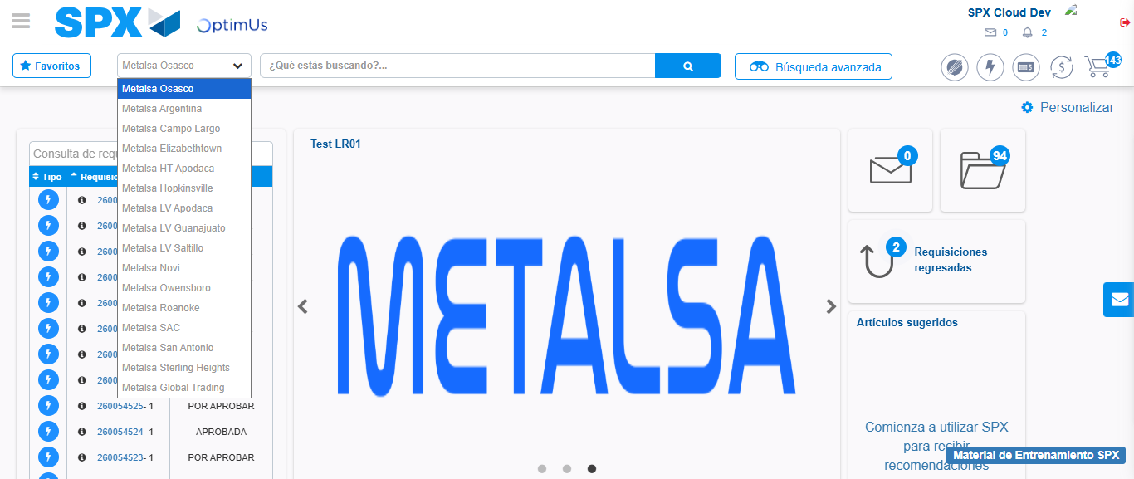Image file-name: QC_Testing-tc003_SPX_Dev5_Crear_Requisicion_Spot_Tipo_Cobro_CC_Urgent-1782242798654

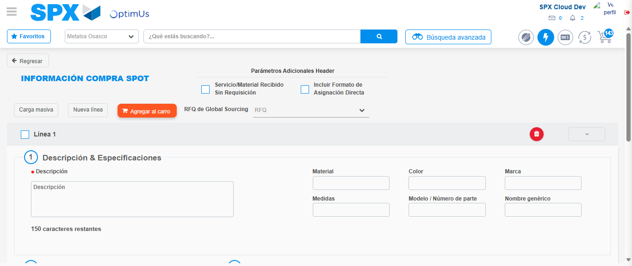Image file-name: QC_Testing-tc003_SPX_Dev5_Crear_Requisicion_Spot_Tipo_Cobro_CC_Urgent-1782242822868

Step 3 - Data Capture Spot Buy Requisition: Data captured correctly
Image file-name: QC_Testing-tc003_SPX_Dev5_Crear_Requisicion_Spot_Tipo_Cobro_CC_Urgent-1782242823156

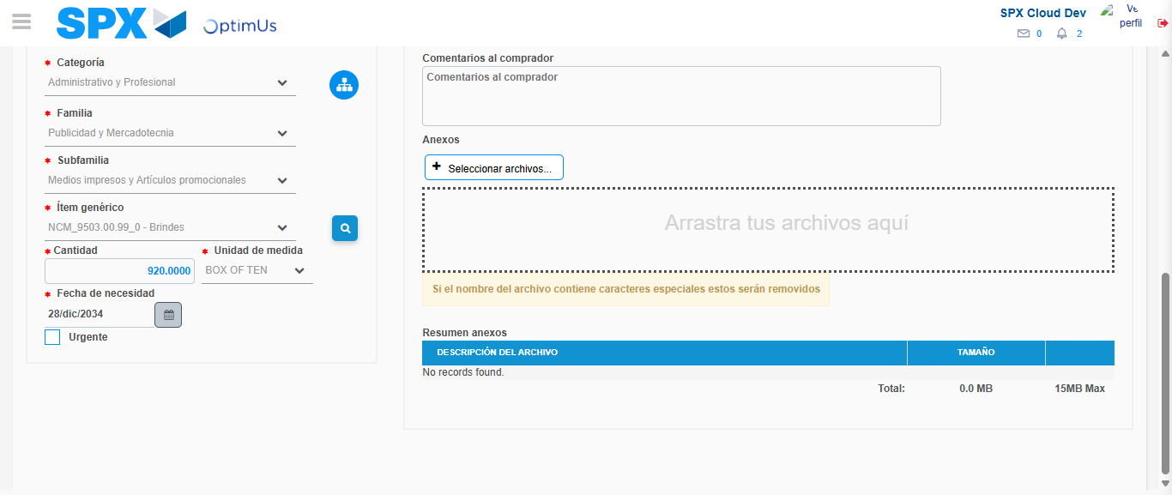Image file-name: QC_Testing-tc003_SPX_Dev5_Crear_Requisicion_Spot_Tipo_Cobro_CC_Urgent-1782242836866

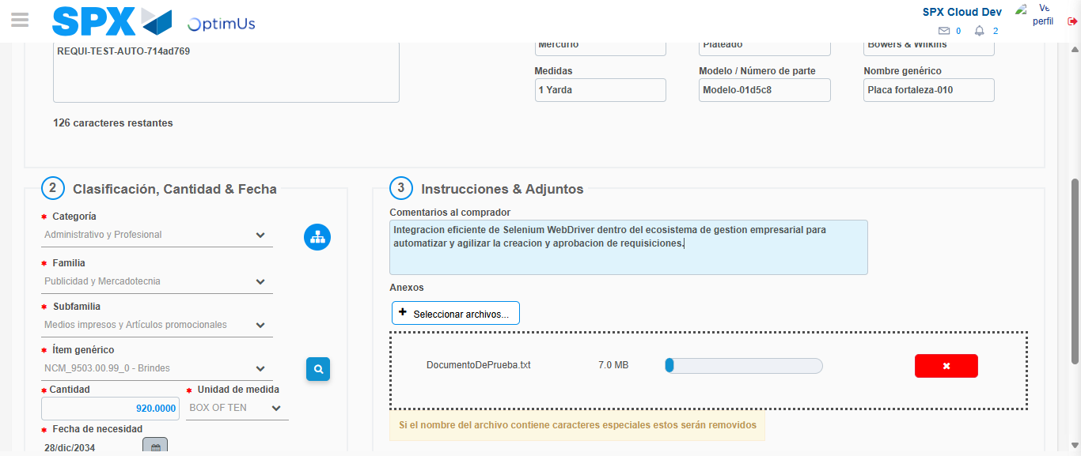Image file-name: QC_Testing-tc003_SPX_Dev5_Crear_Requisicion_Spot_Tipo_Cobro_CC_Urgent-1782242837767

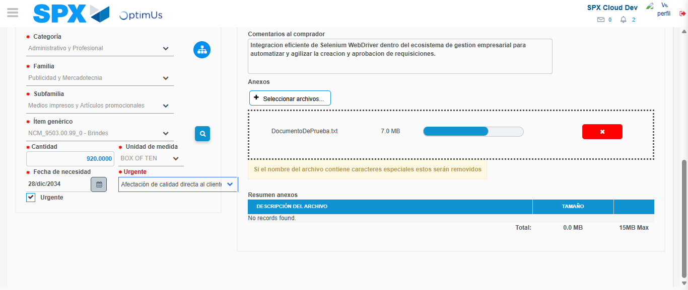Image file-name: QC_Testing-tc003_SPX_Dev5_Crear_Requisicion_Spot_Tipo_Cobro_CC_Urgent-1782242841685

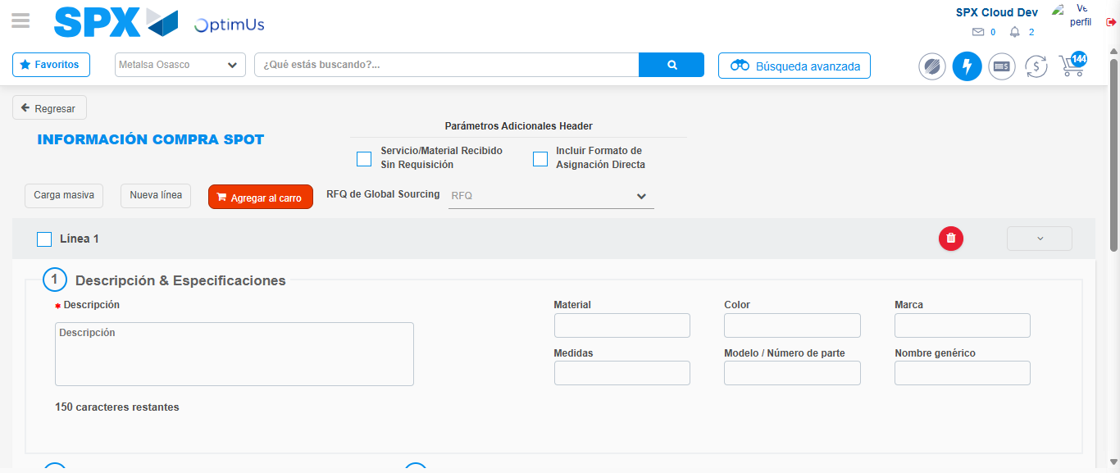Image file-name: QC_Testing-tc003_SPX_Dev5_Crear_Requisicion_Spot_Tipo_Cobro_CC_Urgent-1782242854154

Step 7 - Return to Main Page SPX : Return to Main Page SPX
Image file-name: QC_Testing-tc003_SPX_Dev5_Crear_Requisicion_Spot_Tipo_Cobro_CC_Urgent-1782242796056

Image file-name: QC_Testing-tc003_SPX_Dev5_Crear_Requisicion_Spot_Tipo_Cobro_CC_Urgent-1782242798654

Image file-name: QC_Testing-tc003_SPX_Dev5_Crear_Requisicion_Spot_Tipo_Cobro_CC_Urgent-1782242822868

Image file-name: QC_Testing-tc003_SPX_Dev5_Crear_Requisicion_Spot_Tipo_Cobro_CC_Urgent-1782242856409

Image file-name: QC_Testing-tc003_SPX_Dev5_Crear_Requisicion_Spot_Tipo_Cobro_CC_Urgent-1782242856604

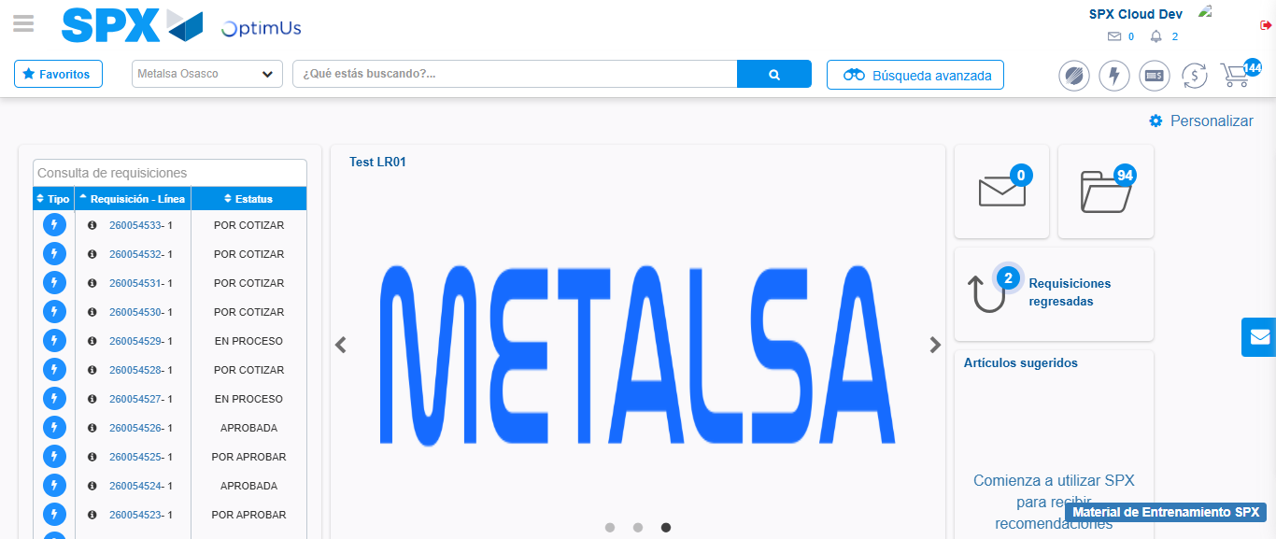Image file-name: QC_Testing-tc003_SPX_Dev5_Crear_Requisicion_Spot_Tipo_Cobro_CC_Urgent-1782242878225

Step 8 - Log Out : Log Out SPX
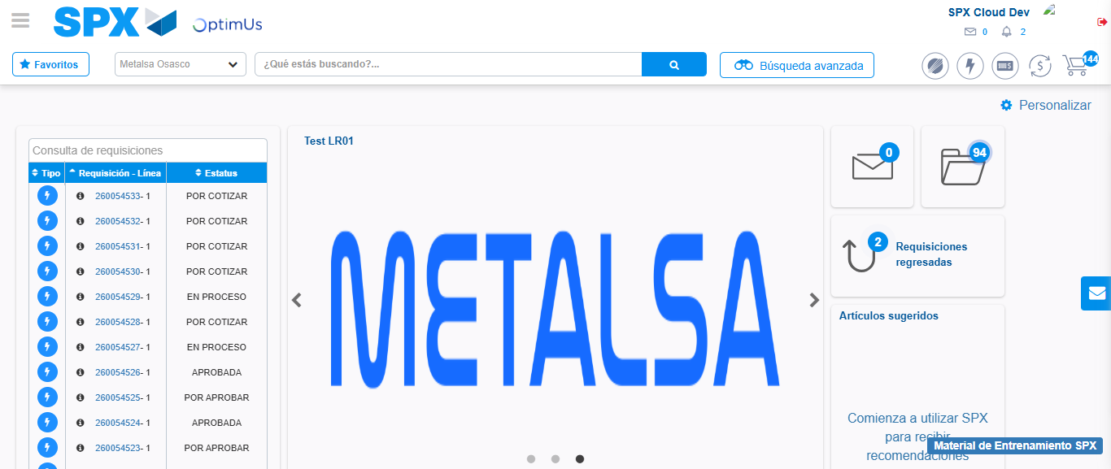Image file-name: QC_Testing-tc003_SPX_Dev5_Crear_Requisicion_Spot_Tipo_Cobro_CC_Urgent-1782242878532

